Task 1

INCLUDE Irvine32.inc

.code

main PROC

mov eax, 10h

mov ebx, 20h

mov ecx,ebx

mov edx,eax

mov ebx,edx

mov eax,ecx

call WriteDec

exit

main ENDP

END main

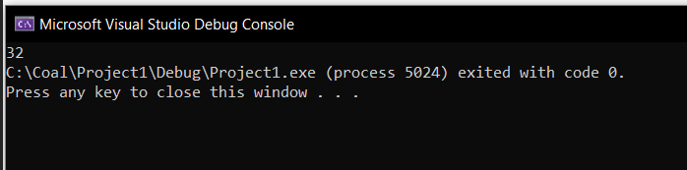

Task 2

INCLUDE Irvine32.inc

.code

main PROC

mov eax, 15

mov ebx, 25

add eax,ebx

call WriteDec

exit

main ENDP

END main

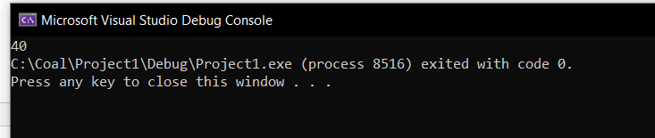

Task 3

INCLUDE Irvine32.inc

.code

main PROC

mov eax, 5

mov ebx, 28

imul eax,ebx

call DumpRegs

exit

main ENDP

END main

